Mathematical Solution

🌟 Definition
# Source: AI Source: Provided by: [Data Path: Persons Table -> ID Column: 1, Name_En Column: Motasem Essam] -> From: [ChatGPT] on [5/29/2026]
A mathematical solution is the result or answer obtained after solving a mathematical problem, equation, or system using logical reasoning, formulas, or mathematical methods.
It shows the value(s) or conclusion that satisfies the given conditions of the problem.

🎯 Purpose of a Solution
# Source: AI Source: Provided by: [Data Path: Persons Table -> ID Column: 1, Name_En Column: Motasem Essam] -> From: [ChatGPT] on [5/29/2026]
- To answer a mathematical problem
- To determine unknown values
- To verify conditions of an equation or system
- To complete problem-solving processes
- To confirm whether a statement is true or false

📚 Key Characteristics
# Source: AI Source: Provided by: [Data Path: Persons Table -> ID Column: 1, Name_En Column: Motasem Essam] -> From: [ChatGPT] on [5/29/2026]
A mathematical solution:
- Satisfies the original problem or equation
- Can be a number, expression, set, or proof
- May have one solution, multiple solutions, or no solution
- Must be verified by substitution or logic
- Is derived through mathematical steps

🧩 Types of Mathematical Solutions

1. Exact Solution
# Source: AI Source: Provided by: [Data Path: Persons Table -> ID Column: 1, Name_En Column: Motasem Essam] -> From: [ChatGPT] on [5/29/2026]
A precise answer written in simplest form.
Example:
$$x=5$$

2. Approximate Solution
# Source: AI Source: Provided by: [Data Path: Persons Table -> ID Column: 1, Name_En Column: Motasem Essam] -> From: [ChatGPT] on [5/29/2026]
A rounded or estimated answer.
Example:
$$π≈3.14$$

3. General Solution
# Source: AI Source: Provided by: [Data Path: Persons Table -> ID Column: 1, Name_En Column: Motasem Essam] -> From: [ChatGPT] on [5/29/2026]
Represents all possible solutions.
Example:
$$x=nπ, n∈Z$$

4. No Solution
# Source: AI Source: Provided by: [Data Path: Persons Table -> ID Column: 1, Name_En Column: Motasem Essam] -> From: [ChatGPT] on [5/29/2026]
When no value satisfies the problem.
Example:
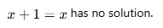
$x+1=x$ has no solution.

🧩 Steps to Find a Solution
# Source: AI Source: Provided by: [Data Path: Persons Table -> ID Column: 1, Name_En Column: Motasem Essam] -> From: [ChatGPT] on [5/29/2026]
- Understand the problem
- Identify known and unknown values
- Choose the correct method (formula, equation, logic)
- Solve step by step
- Verify the result
- Write the final answer

🔗 Relationship to Other Concepts
# Source: AI Source: Provided by: [Data Path: Persons Table -> ID Column: 1, Name_En Column: Motasem Essam] -> From: [ChatGPT] on [5/29/2026]
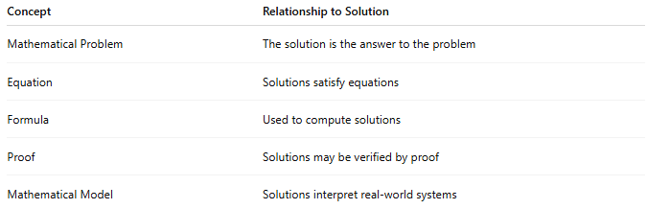
Concept | Relationship to Solution
Mathematical Problem | The solution is the answer to the problem
Equation | Solutions satisfy equations
Formula | Used to compute solutions
Proof | Solutions may be verified by proof
Mathematical Model | Solutions interpret real-world systems

📖 Solution vs Problem vs Equation
# Source: AI Source: Provided by: [Data Path: Persons Table -> ID Column: 1, Name_En Column: Motasem Essam] -> From: [ChatGPT] on [5/29/2026]
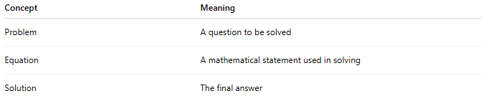
Concept | Meaning
Problem | A question to be solved
Equation | A mathematical statement used in solving
Solution | The final answer

🧠 Simple Analogy
# Source: AI Source: Provided by: [Data Path: Persons Table -> ID Column: 1, Name_En Column: Motasem Essam] -> From: [ChatGPT] on [5/29/2026]
A mathematical solution is like the final result of a puzzle:
- Problem = puzzle
- Steps = reasoning
- Solution = completed picture

🧭 Summary
# Source: AI Source: Provided by: [Data Path: Persons Table -> ID Column: 1, Name_En Column: Motasem Essam] -> From: [ChatGPT] on [5/29/2026]
A mathematical solution is the answer or result obtained after solving a mathematical problem or equation. It shows the value or conclusion that satisfies the given conditions and completes the problem-solving process.

